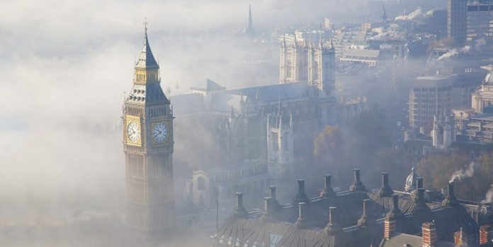

1. **Introduction:**

1.1 Background

London’s air pollution rarely hit headlines around the world but in fact the city has been persistently breaching the EU and UK air pollution limits every year.

Two main pollutants that contribute to London’s air pollution and have bad impacts on human health and environment are: Nitrogen dioxide (NO2) - a gas that is caused mainly by diesel vehicles and particular matter (PM) - particles with varying shape, size and composition that come from residential and commercial combustion. Long term exposure to these two pollutants can cause lung and heart diseases, respiratory infections and reduced life expectancy. [2] Recent studies show that there is a correlation between coronavirus deaths and the level of air pollution, with London and the Midlands are examples. [3]

The UK went into lockdown on 23 March 2020 in an effort to curb the spread of coronavirus and ever since there are news and reports on the reduction of air pollution in London.

1.2 Problem:

This report aims to analyse whether the level air pollution in London has decreased since the Covid-19 lockdown and analyse whether air pollution has a strong correlation with possible sources.

It is for everyone who have read news about the reduction in air pollution since lockdown to understand what it really means and for local authorities to have an insight to the borough profiles and develop solutions to tackle air pollution at the local level.

**2. Data sources, data cleaning and assumptions**

* 1. Data sources
     + NO2, PM2.5, and PM10 data: The London Air Quality Network (LAQN) measure and record air pollution in different monitoring sites across London. The data for NO2 and PM2.5 for the period from 23 February 2020 to 26 April 2020 and the same period in 2019 were obtained from the London Air - LAQN’s website. This is used to compare air pollution in London one month before and after lockdown. [4]
     + London traffic index: I scraped the traffic flows data in 2019 and 2020 from an article from The Guardian of which the main data source is from TomTom to analyse the correlation between London traffic flows and the level of NO2 and PM2.5 in London.[5]
     + Coordinates of London boroughs: I downloaded a json file from GitHub to create a choropleth map of NO2 and PM10 level and a cluster map of London boroughs.[6]
     + London borough profiles: The dataset was published by the Greater London Authority (GLA) that contains demographic, economic, social and environmental information for each borough in London and City of London. I used this for clustering boroughs and determine whether it has any correlation to the level of air pollution by PM10. [7]
     + London energy consumption in 2017: This dataset was also obtained from the GLA and will be merged into the London borough profiles data as energy consumption is also one of the causes of air pollution. [8]
  2. Data cleaning and assumptions

The NO2, PM2.5, PM10 data obtained from LAQN did not require a lot of data cleaning. I did however have to manually changed the site ID codes to the borough names in order to visualise the data on the map. I also made three assumptions regarding this dataset: (1) The data from the monitoring site is representative of the borough. This is because some boroughs have more than one monitoring sites. (2) For six boroughs that do not have

monitoring sites (no data) for NO2, I have assumed that the NO2 level is the average of all 27 boroughs’ NO2 level. (3) As there is no sufficient dataset available for PM2.5 or PM10 in 2017, I used PM10 data in 2019 instead even though there are 12 boroughs that do not have records of PM10, so I chose different monitoring sites from the nearby boroughs.

It is also worth noting that the data is provisional, i.e. has not been ratified by LAQN.

The traffic index data was scraped by inspecting the page source of the Guardian’s article. I downloaded the json file and converted it to csv file. The traffic index was updated hourly, so I averaged this out to get the daily index and since it covered the period from January 2020, I sliced the data to get only the relevant period (23 February to 26 April 2020).

Regarding London borough profiles data, there is a lot of information, but I only need information that may have effects on air pollution such as population, number of cars per household, etc so I only got relevant columns from this large dataset. I then merged this with the London energy consumption in 2017 since the borough profiles information contain information in 2017 or in earlier years.

**3. Methodology**

**3.1 Exploratory data analysis**

A. London traffic flows one month before and after the Covid-19 lockdown

It is clear from the graph that the traffic flows in London dropped dramatically since lockdown rules were imposed on 23 March 2020 (red line) and were less than half of that in the same period in 2019 (blue line).

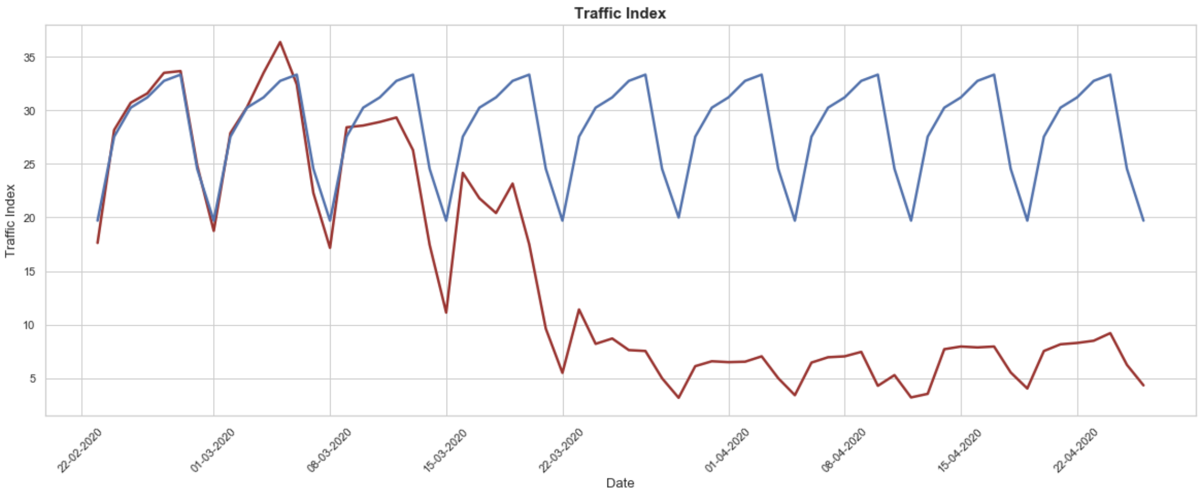

B. London air pollution by NO2 one month before and after the Covid-19 lockdown

As the main source of air pollution by NO2 in the city is from the use of diesel vehicles (fuel combustion), it should be expected that traffic reduction will also reduce the level of NO2 in London.

I utilised Python’s seaborn library to plot a line graph of the NO2 data in 2020. For simplicity, I only chose data for six boroughs: Camden, City of London, Greenwich, Hillingdon, Wandsworth and Westminster.

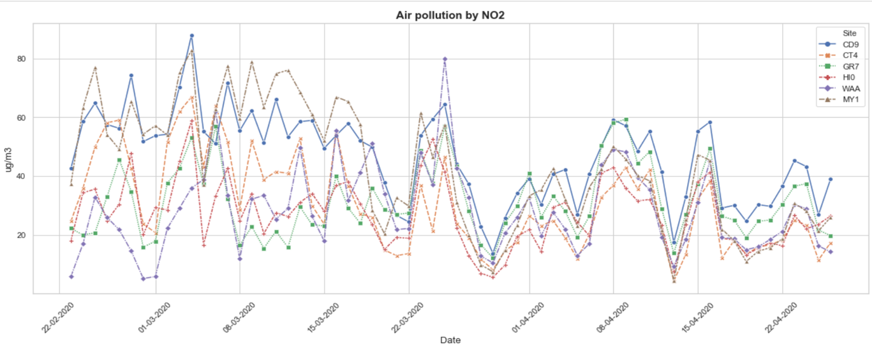

Figure 1. Air pollution by NO2 from February to April 2020

The graph shows that the level of NO2 decreased quite significantly during the lockdown period, especially in the two busy boroughs - Camden and Westminster. The EU limit for NO2 for protection of human health is 40ug/m3 annual mean however it is clear from the graph that some sites are set to breach this limit if lockdown is not in place. [8]

I also used Python’s folium library to create the choropleth map of the NO2 level across London boroughs. The below map shows that the level of NO2 is high in Central London (dark red).

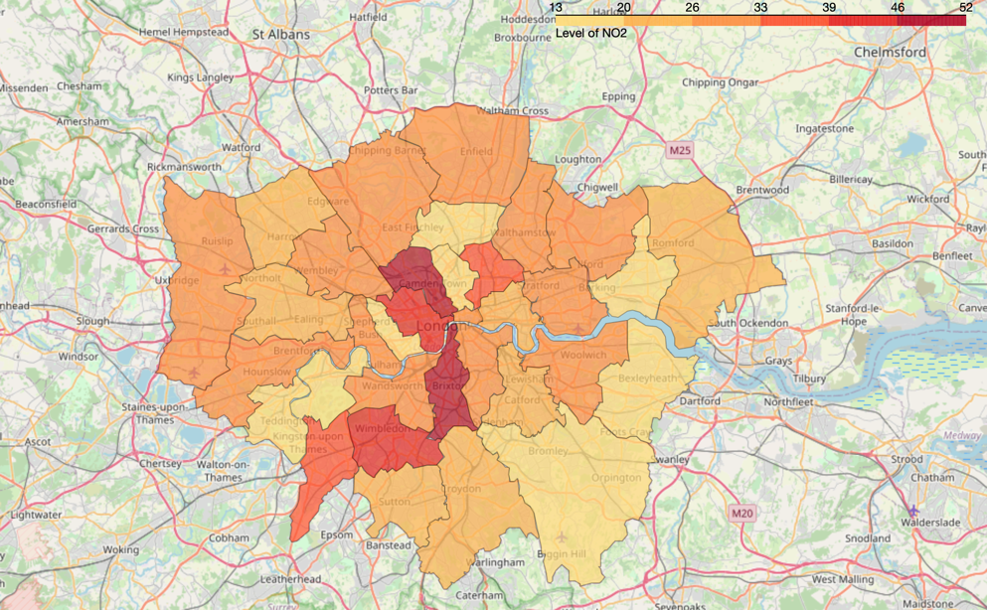

Figure 2. Choropleth map of NO2 concentration across London boroughs

If we then compare this period with the same period in 2019 by using box plot to demonstrate the distribution of NO2 level across the six sites between two years, we can see a stark difference. For instance the level of NO2 in the City of London decreased considerably: from having a minimum of NO2 concentration of nearly 60 ug/m3 to 20 ug/m3 and a maximum of 80 ug/m3 to just above 40ug/m3 in 2019 and 2020 respectively.

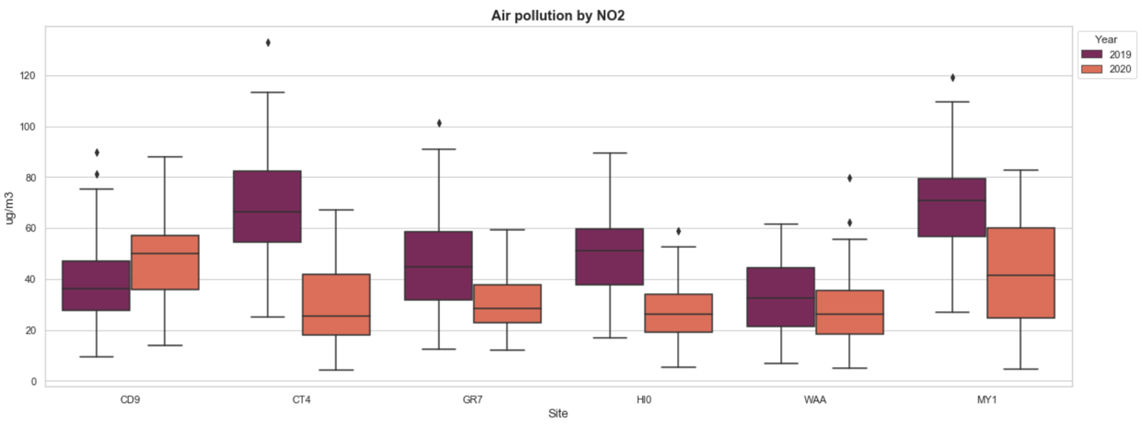

Figure 3. Air pollution by NO2 between 2019 and 2020 (February to April)

You may wonder why the level of NO2 increased in the first site – Camden. This is because 2019 data was not available for the monitoring site in Euston Road so I collected data for the site in Bloomsbury Street instead to represent Camden borough and I know from my experience studying in the area, Euston Road is much more congested than Bloomsbury Street.

C. Relationship between traffic flows and the level of NO2

I used regression plot for the traffic index and NO2 data (I collated NO2 data for all boroughs so that it will be more compatible with traffic data) to analyse the strength of the relationship between the two variables. The Pearson Correlation Coefficient is 0.3964898157393618 with a P-value of P = 0.001180930281446588. This indicates that they are positively correlated however not strongly correlated as I expected.

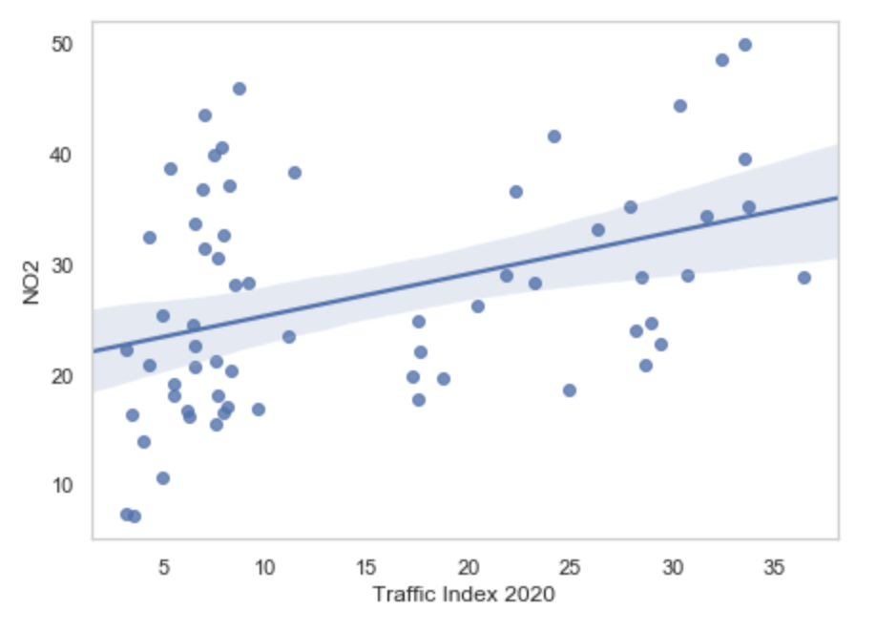

Figure 4. Regression plot for traffic and NO2 data

D. London air pollution by PM2.5 one month before and after the Covid-19 lockdown

Particular matter 2.5 or fine particular matter refers to tiny air droplets with a diameter less than 2.5 micrometres (any particular matter with a diameter less than 10 micrometres is harmful). So far, we have seen a reduction in traffic flows and NO2 level in London as a result of lockdown, this however does not apply to the level of PM2.5. In contrast, the level of PM2.5 increased during this period as shown from figure 5.

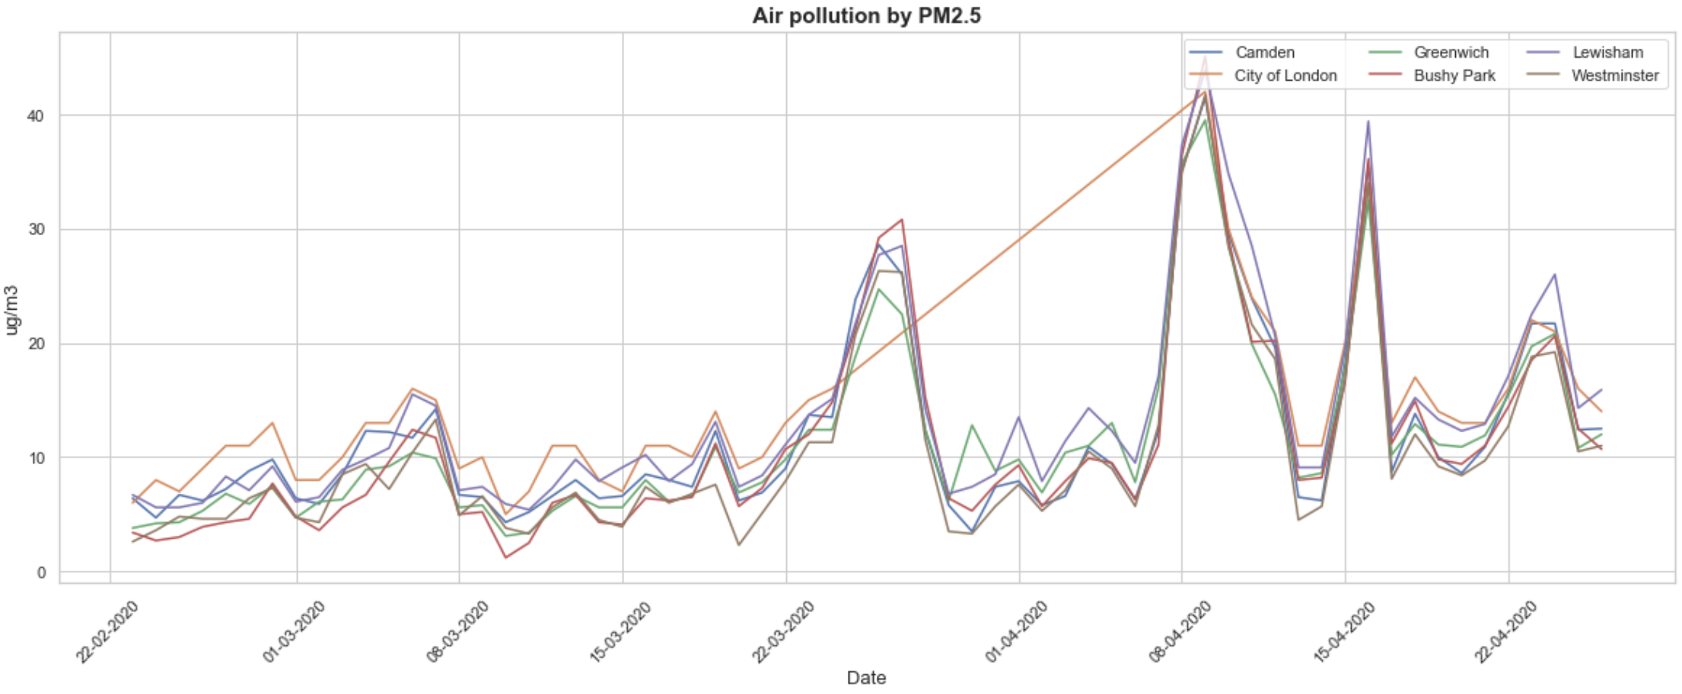

Figure 5. Air pollution by PM2.5 from February to April 2020

Why? We know that PM is produced mainly from either of residential or commercial combustion, so it may have been a combination of house BBQs, bonfire nights, road vehicles’ emission and industrial emissions. Hence, even though traffic flows decreased significantly since lockdown, there are other human activities that are still contributing to air pollution in London during this period.

The good news is if we place this next to the 2019 data, the level of PM2.5 actually decreased in 2020 and remained below 50ug/m3. The bad news is we may still not be able to meet the UK and EU air quality limit for PM2.5 which is 25ug/m3 annual mean by 2020.

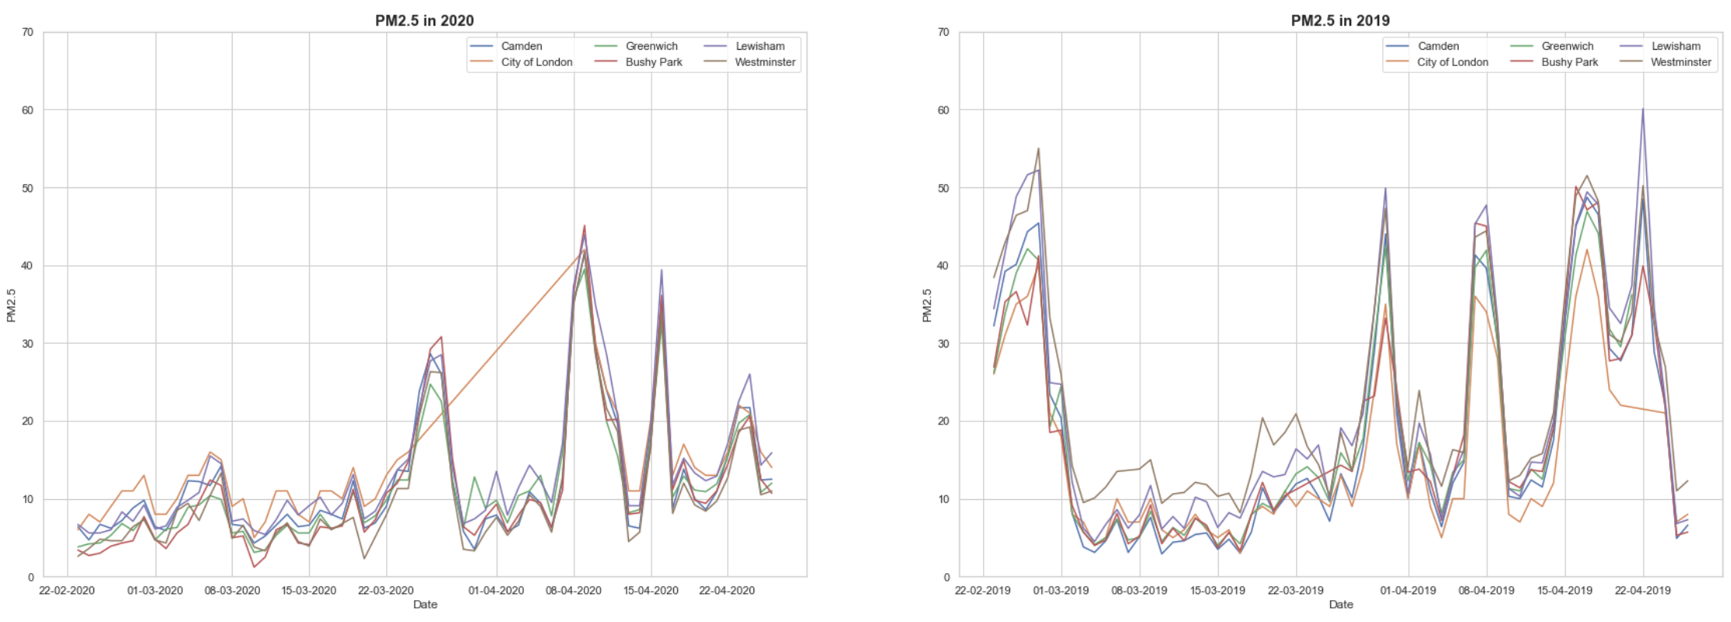

Figure 6. Air pollution by PM2.5 between 2019 and 2020

**3.2. Predictive data analysis**

A. Regression model

My hypothesis is that the regression model would be a good model to predict the level of NO2 based on traffic data (with traffic flows being the independent variable (X) and the NO2 level being the dependent variable(Y)). I used the scikit-learn machine learning module to implement linear regression.

The structure of the linear model is: 𝑌=𝑎+𝑏𝑋. In our context, it is: **NO2** = a + b**TRAFFICINDEX**

After using fit() method to fit X and Y to the linear regression model, I was able to get the value of intercept and slope. Plugging the actual values, we get an equation: **NO2=21,464-0,3809TRAFFICINDEX**

B. Machine learning

As mentioned earlier, there are other human activities that still contribute to air pollution by PM in London, I want to know if there is a relationship between London boroughs’ characteristics and the level of air pollution by PM in these boroughs.

As such, from the London borough profiles dataset, I chose information that may have some relations to the level of PM and merged the London energy consumption data in 2017. The merged data frame is as follows:

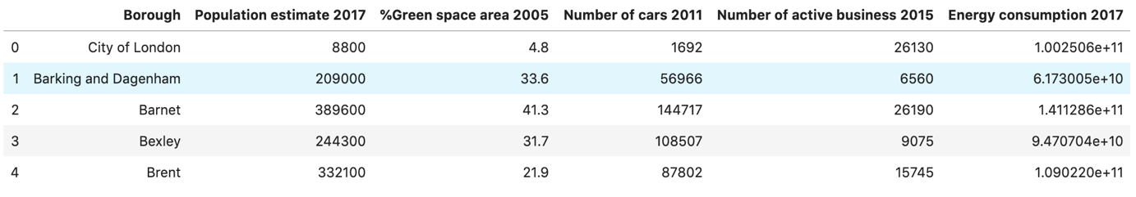

I standardised the data and used K-means clustering to categorise London boroughs into different clusters. The optimum k of the K-means I obtained from the Elbow method is 4 degree so 32 boroughs (and City of London) will be clustered into 4 clusters.

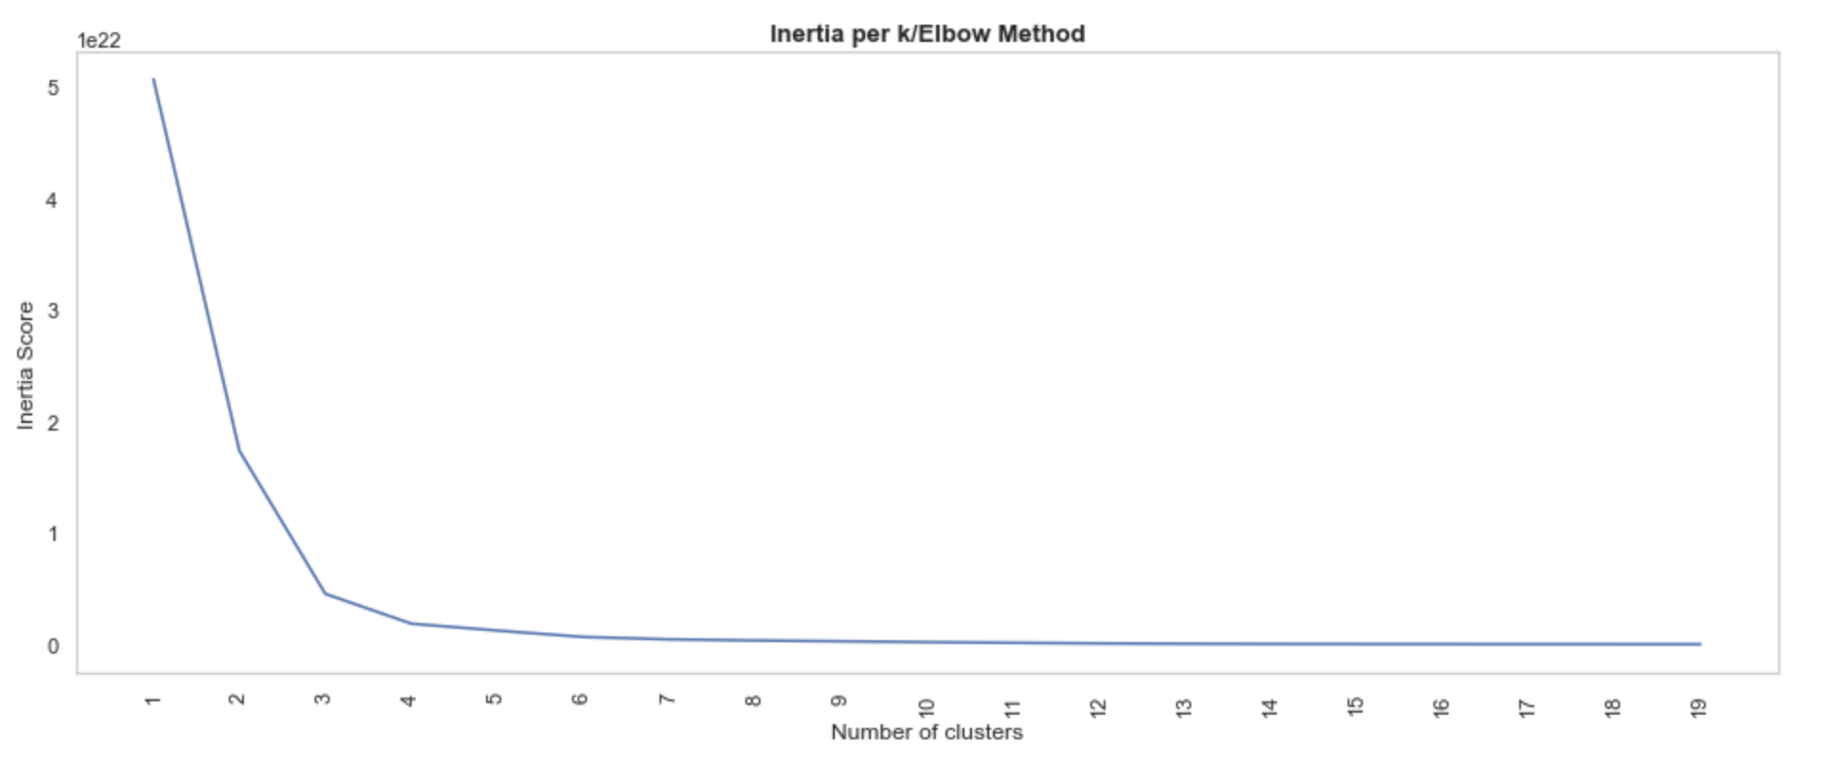

Figure 7. Elbow method for optimal k

I added cluster labels to the table:

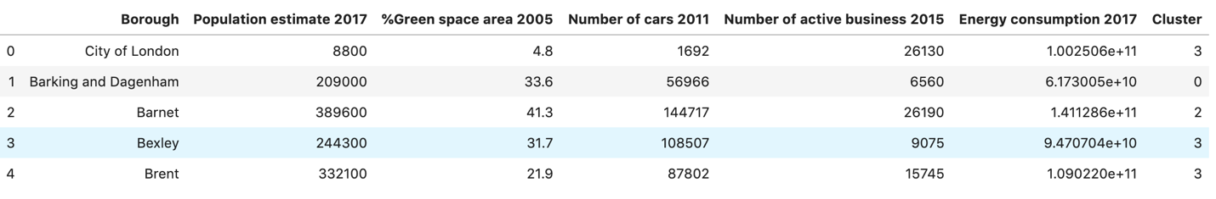

Next, I merged the coordinates of London boroughs from the following data frame (I extracted from the json file) to the above table in order to visualise clusters on London map.

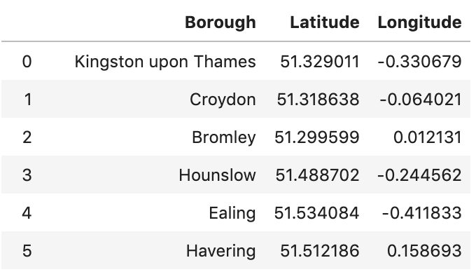

I then used Python’s geopy library to get London’s geographical coordinates and folium library to illustrate clusters on the map (Figure 8). Finally I added a choropleth map of the PM10 data in 2019 to the map of clusters (Figure 9).

5. Results

To evaluate the performance of the regression model to predict the level of NO2, I used two evaluation metrics: R-square and mean square error. The value of R-square is 0.15720417398503317. This means 15,72% of the variation of NO2 level is explained by this linear model. The mean squared error of the model is 84.17943168559336. This indicates that the fitted line is not quite close to data points and hence model is not an accurate model.

With regards to the k-means clustering of London boroughs, the clusters are shown on Figure 8 and the choropleth map is added in Figure 9 below:

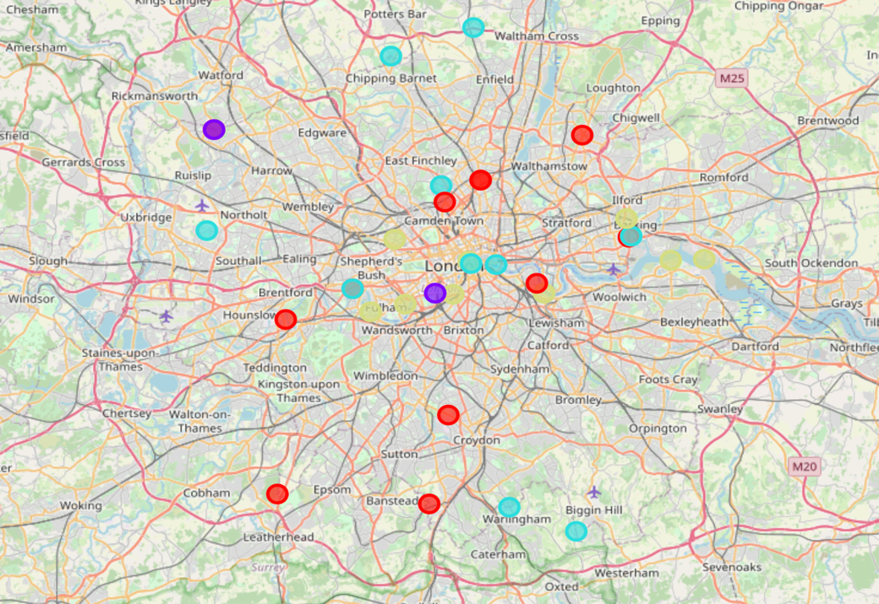

Figure 8. Map of clusters

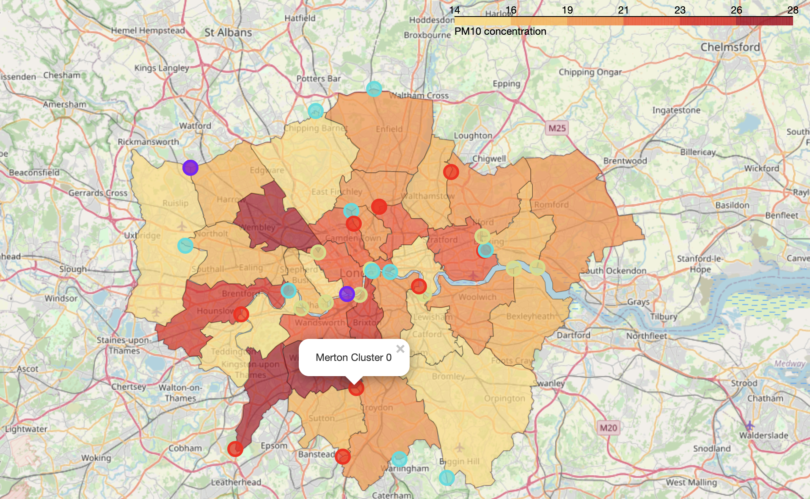

Figure 9. Map of clusters and PM10 concentration

After reviewing four clusters, I can characterise each cluster as follows:

* Cluster 0: Small population and low energy consumption
* Cluster 1: Medium-size population and high energy consumption
* Cluster 2: Large population and moderate energy consumption
* Cluster 3: Medium-size population and low energy consumption

As mentioned, I wanted to know if borough profiles can tell us something about the level of air pollution by PM in the area. The result is not quite what I have expected. It does show that some boroughs in the same cluster have similar level of air pollution by PM10, but some clusters don’t. I also expect that the level of PM10 would be high in two boroughs of cluster 1: Hillingdon (Heathrow airport) and Westminster (Marylebone) as energy consumption is significantly higher than other boroughs.

6. Discussion

Model limitations: The relationship between NO2 and traffic flows is not as strong as I expected and this may have been because of the dataset I used to fit into the model. First, the daily traffic index which measures how congested London is may not be a good data input because it does not mean that the use of vehicles has been reduced during lockdown. Hence if we have a better data source for this model, I expect we could build a better model. Second, the level of NO2 may also be produced from other sources as well so it could be the case that other models will be better suited. Third, both data used for modelling is for a short period of time and as such it is difficult to build an accurate model. Given more time, I would use different datasets to train and test the model and take into account other possible sources that produce NO2.

For the k-means clustering and my attempt to show the relationship between boroughs’ characteristics and the level of air pollution by PM in each borough, the problem I found is the quality of data as well. One of my assumption I mentioned is for boroughs that do not have PM monitoring sites, I used the PM data of the nearby borough that has more than one monitoring site. In addition, the PM data is not fully available for 2017 and hence I collected 2019 data instead. It is not compatible with the year of London borough profiles dataset. In the future, I expect we will have a better access to more accurate and sufficient data for better analysis.

7. Conclusion:

In this report, I analyse the correlation between London traffic flows and air pollution by NO2 and PM2.5 one month before and after the Covid-19 lockdown. I attempt to build a regression model to predict the level of NO2. For an air pollutant that its source is not mainly from the use of vehicles but from other human activities (PM), I use machine learning to test whether London boroughs’ characteristics have any relations to the level of this air pollutant. With the results I achieve, it shows that there is a positive correlation between NO2 level and traffic level in London and it seems that certain London boroughs in the same category share similar level of air pollution however further testing is needed for this hypothesis to be confirmed.

The findings of this project I hope is to promote environmental awareness among us as we see how much we contribute to air pollution. Local authorities are putting measures in place to protect the local environment however the most important factor is still us all. Let’s make our environment greater again.

8. References:

[1] <https://bigthink.com/strange-maps/london-air-quality-pollution-health?rebelltitem=6#rebelltitem6>

[2] <https://www.gov.uk/government/publications/health-matters-air-pollution/health-matters-air-pollution>

[3]<https://airqualitynews.com/2020/04/22/scientists-link-england-coronavirus-deaths-with-exposure-to-toxic-air/>

[4] <https://www.londonair.org.uk/london/asp/datadownload.asp>

[5] <https://www.theguardian.com/world/ng-interactive/2020/apr/27/the-traffic-data-that-shows-the-road-into-and-out-of-covid-19-lockdown>

[6] <https://skgrange.github.io/www/data/london_boroughs.json>

[7] <https://data.london.gov.uk/dataset/london-borough-profiles>

[8] <https://data.london.gov.uk/dataset/leggi>

[9] <https://uk-air.defra.gov.uk/assets/documents/Air_Quality_Objectives_Update.pdf>

[10] Photo: <https://www.roofingtoday.co.uk/london-air-quality-worse-indoors-than-on-the-streets-according-to-new-research/>